**Draft Entity Relationship Diagram**

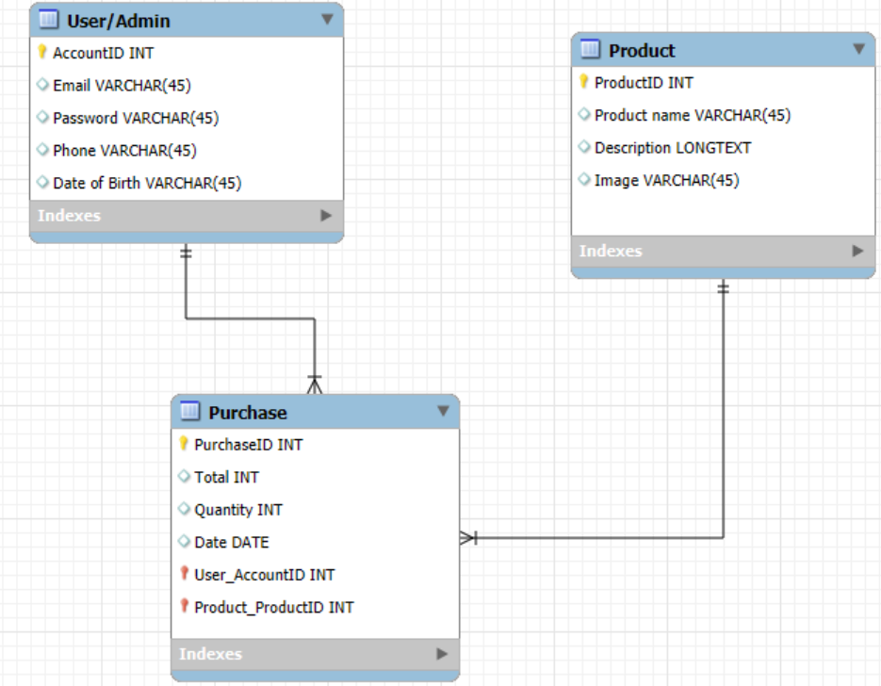

**Annotated Use Case Specifications**

**View Pages**

Displays description and price of product. (Description, Price → Product table)

Display images of products. (Image → Product table)

**Login/Register**

Customers will provide email and password. (Customer → User table, Email & Password → User table)

Authentication of customer. (Authentication → System process for verifying Customer table records)

Administrator will use username and password. (Admin → Admin table, Username & Password → Admin table)

Authentication of the admin. (Authentication → System process for verifying Admin table records)

**Add Products**

Admin can add products to the products page using the database connected. (Admin → Admin table, Product → Product table, Database → Storage medium for Product table)

**Remove Products**

Admin can remove products from the products pages. (Admin → Admin table, Product → Product table)

**History of Transaction**

History of purchases of customers will be provided using the database. (History and Purchases → Purchase table, Customer → Customer Table, Database → System storage for Purchase table)

**Cancellation of Transaction**

Customer can enter transaction details. (Customer → User table, Transaction Details → Purchase table)

System makes request to the database to search the exact transaction. (System → Application logic, Search → Query to Purchase table, Transaction → Purchase table, Database → Data storage)

Database returns the transaction details to the system. (Database → Purchase table, Returns → Data retrieval process)

System displays Purchase to the customer. (System → Application, Purchase → Retrieved Transaction Data, Customer → User Table)

Customer must confirm the transaction. (Customer → Customer Table, Confirm → Change status in Purchase table)

Database deletes the transaction. (Database → Purchase table, Delete → Remove record)

Database sends the refund to the system. (Database → Purchase table, Refund → Status Update in Purchase table)

System sends refund information to the customer. (System → Application, Refund Info → User table record)

**Sales**

Customers can view products that are on sale. (Customer → Customer table, Product → Product table, Sale → Sale Status in Product table)

Admin can stock products that are on sales on the website. (Admin → Admin table, Product → Product table, Sale Status → Product table Update)

**Checkout**

Display the list of products alongside the price. (Display → Website, List of Products → Product table, Price → Product table Update)

Breaks the entire cost of the purchase to the customer. (Breaks → Calculation Logic, Cost → Aggregated Product Prices, Purchase → Purchase table, Customer → User Table)